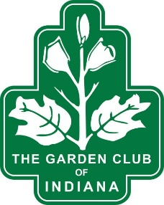
REGISTRATION FORM
THE GARDEN CLUB OF INDIANA, INC
2026 Fall Native Seminar
“LET’S GO NATIVE”
Wednesday, September 9, 2026
HOSTED BY SOUTHWEST DISTRICT GARDEN CLUBS LYLES STATION HISTORIC SCHOOL AND MUSEUM,
953 N COUNTY RD 500 WEST, PRINCETON, IN

Registration Deadline: Sunday, August 9, 2026
Registration Fee: $40.00 Make check payable to:
Includes morning beverage, snack, and lunch The Garden Club of Indiana, Inc.

Mail check with completed registration form to: TGCI Registration
Postmarked by August 9, 2026 c/o Jodi Meyer
2400 Taylor Ave
Princeton, IN 47670

Spouses and Guests are welcome. A separate registration form is required for each attendee.
Questions about Registration? Email: jodilume57@gmail.com

Name: ________________________________________________________________________________

Address: _______________________________ City: __________________________ Zip: ____________

Phone: ________________________________ Email: ________________________________________

Club Name: ___________________________________________ Club District: ___________________

Check if applicable: Spouse: ____ Guest: ____ State Officer: _____ Other (List): _______________
Emergency Contact: ________________________________________ Phone: _____________________

Those arriving Tuesday evening are invited to a Campfire Social, 6:30-8pm at Lyles Station, 953 N County Rd 500 West, Princeton, IN. Dinner and drinks $7.00 each. Attending Campfire Social? YES ____ NO _____
Available Lodging: Room reservations should be made directly with Princeton hotels.
Hampton Inn, Princeton: 812-385-2400; Holiday Inn Express, Princeton: 812-385-4300
Gibson County Fairgrounds: 812-385-3445 (camping sites available)
DISPLAYS AND EXHIBITS: If you wish to have space for an exhibit, please complete following:
Project or Exhibit Name: ____________________________________Table Space needed______________

